Table of Contents
Introduction 5
TASK 1 5
System Design 5
Scope and target users 5
System functions and output design 6
Types of anomalies considered 7
Architecture, data flow, storage and processing 8
Anomaly Detection Algorithm 9
Data preprocessing strategy 9
Algorithms tested 11
Final algorithm selection and justification 13
TASK 2 14
System Implementation 14
Programming language and development environment 14
Data acquisition and preparation 14
Model training and optimization 16
Implementation workflow and generated artefacts 18
Implementation challenges 19
Evaluation and Testing 20
Future Perspective 27
Conclusion 27
References 28
AI-use declaration 30
Appendices 30
Appendix A: Additional figures 30
Appendix B: CSV and output evidence 32

List of figures:
Figure 1. System architecture for the CCTV violence anomaly detection system 8
Figure 2. Balanced class distribution of normal and anomaly images 9
Figure 3.Code used to create the class distribution chart shown in Figure 2 9
Figure 4. Sample normal and anomaly images from the prepared dataset 14
Figure 5. Code used to sample and display normal/anomaly images 15
Figure 6. MobileNetV2 training and validation accuracy curve 16
Figure 7. Code used to generate the MobileNetV2 accuracy and validation curves shown in Figures 6 16
Figure 8. MobileNetV2 training and validation loss curve 17
Figure 9. Code used to generate the MobileNetV2 training and validation loss curve shown in Figure 8 17
Figure 10. Final F1-score comparison across all tested models 20
Figure 11. Code used to generate the final F1-score model comparison shown in Figure 10 20
Figure 12. Confusion matrix for the selected MobileNetV2 model 22
Figure 13. Code used to evaluate MobileNetV2 and generate the confusion matrix shown in Figure 12 22
Figure 14. ROC curve for the MobileNetV2 model 24
Figure 15. Code used to generate the MobileNetV2 ROC curve shown in Figure 14 24
Figure 16. Precision-recall curve for the MobileNetV2 model 25
Figure 17. Python code for calculating average precision and generating the MobileNetV2 precision-recall curve in Figure 16 25
Figure 18. Example alert demonstration using test images 26
Figure 19. Code used to generate the security alert log and alert demonstration shown in Figure 18 26

List of tables:
Table 1. System requirements and design decisions 4
Table 2. Anomaly types considered in the project 5
Table 3. Dataset and split summary generated from CSV outputs 7
Table 4. Model selection matrix 10
Table 5. Final model selection evidence from notebook outputs 11
Table 6. MobileNetV2 training history summary from CSV output 15
Table 7. Implementation workflow and generated outputs 15
Table 8. Final performance comparison of all tested models 17
Table 9. MobileNetV2 confusion matrix from test set 19
Table 10. MobileNetV2 class-level classification report 20

Introduction
Security teams are increasingly using CCTV, yet camera systems remain reliant on human intervention to detect and interpret. A busy control room may have several screens running simultaneously, allowing violent behaviour to go unnoticed, or to be discovered too late. This project aims at building a system for the detection of anomalies in CCTV like images, using machine learning, categorizes them as normal/non-violent and anomalous/violent.
Anomaly detection involves finding patterns which do not correspond to normal behaviour. In this project, anomaly detection means separating ordinary non-violent scenes from frames that may require security review. The unusual event is violence, so a normal image represents expected activity and a violent image is treated as a possible alert (Sengonul et al., 2025). For the purposes of this project, violence is considered the unusual occurrence. Normal activity is indicated by a non-violent image, and a possible security alert is indicated by a violent image.
The dataset used is from the Kaggle Violence vs. Non-Violence: 11K Images Dataset containing over 11,000 images of scenes of violence (416 × 416) and non-violence (Kaggle, n.d.). A balanced working sample of 5,000 images (2,500 images per class) was used. Eight approaches were compared: Isolation Forest, KNN, Linear SVM, Logistic Regression, Random Forest, MLP, small CNN and MobileNetV2 transfer learning. This enabled the project to try classical machine learning and deep learning.

TASK 1

System Design

Scope and target users
The proposed system is an image based CCTV violence anomaly detection system. It does not find individuals, detect faces or follow individuals from camera to camera. Rather, it is fed with a still image and it guesses if the scene in the picture will be normal or violent. This avoids dealing with the problem of biometric identification and helps the project focus on anomaly detection.
The primary users are security control-room operators, campus security personnel, shopping-centre monitors and private security companies. When multiple camera feeds are operating simultaneously, these users require fast response. This system is not designed to take the place of human judgment. It provides information about decision making, including identifying high risk frames to review.
Secondary users: Technical administrators responsible for maintenance of the model, checking false warnings, reviewing logs and updating the system in case of camera condition change. They are crucial because even if a model is built in one environment, without monitoring, it might be unreliable in another one.

System functions and output design
The system has five main functions: image input, preprocessing, model prediction, alert generation and logging. The input in the prototype is a Kaggle image dataset that has been labelled. In a real system, the same logic could be applied in a manner to be connected at fixed time intervals to the frames extracted from CCTV footage.
In the preprocessing, the images are resized and normalised. For classical models, feature arrays are created and for CNN based models, image tensors are used. Prediction Stage: gives a normal/anomaly label and a confidence score. When violence is detected, the system generates a type of alert that can be assessed by a security operator. There was also a notebook-generated security_alert_log.csv, to simulate alert evidence storage.
Table 1. System requirements and design decisions
Requirement area | Final design decision | Evidence / reason
Input | CCTV-style image frame | Matches the image dataset and security scenario
Normal class | Non-violent scene | Represents expected public behaviour
Anomaly class | Violent scene | Represents a security event requiring review
Output | Label + anomaly probability | Gives a clear decision and confidence score
Alert log | security_alert_log.csv | Stores predicted alerts for review
Model family | Classical ML + neural network + transfer learning | Meets the brief’s requirement for algorithm comparison
Final use | Human-reviewed decision support | Reduces risk from false automatic action

Types of anomalies considered
Point, contextual and collective anomalies are taken into account during system design. These are critical because actual security incidents can manifest themselves in various ways. However, this dataset doesn't include video sequences but only still shots, so the realized prototype focuses primarily on testing point anomalies.
Table 2. Anomaly types considered in the project
Anomaly type | Meaning in this system | Implementation status
Point anomaly | One frame shows violence and differs from normal activity | Implemented
Contextual anomaly | Behaviour is suspicious only in a specific time/place situation | Design consideration
Collective anomaly | A sequence/group of events becomes suspicious over time | Future extension

The primary case of this project is a point anomaly. For instance, a single clip of fighting can be interpreted as abnormal, past images will not be needed. Extra metadata (such as location of camera, time of day, event type, number of people in the frame, etc.) would be needed to explain the contextual anomalies. The collective anomalies would be determined by video analysis that would involve more than one frame (showing escalation or group behaviour). They are not all in place in the current prototype but have been included in the architecture as future developments.

Architecture, data flow, storage and processing
The proposed workflow begins with the Kaggle image folders, then creates binary labels, balances the sample, trains the selected models, evaluates their outputs, and finally stores figures, CSV tables and alert records. Data acquisition layer: loading images from Kaggle data set. The preprocessing layer generates labels, rebalances the data set, resizes the images and generates feature arrays or image tensors. In the model layer, you train various algorithms with the same train-validation-test structure. The metrics and figures are derived in the evaluation layer. Predictions, comparison tables and alert logs are stored in output layer.
Figure 1. System architecture for the CCTV violence anomaly detection system
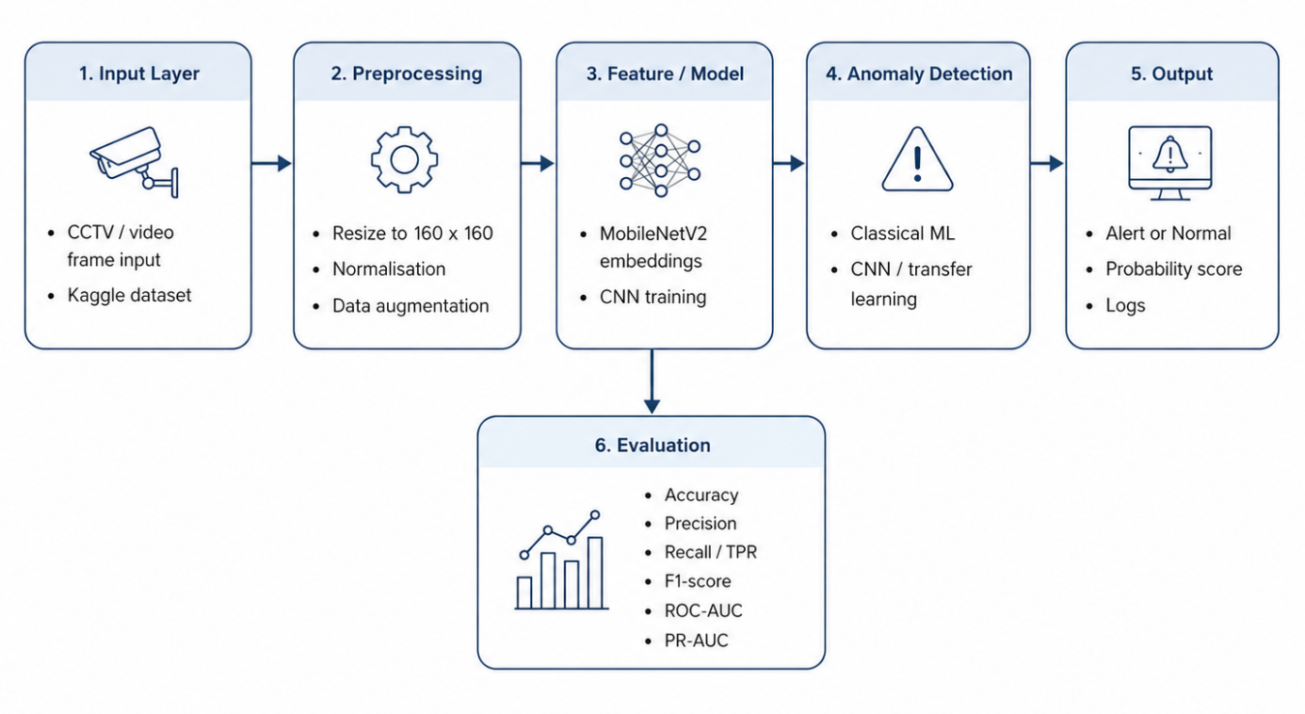
It splits offline and online studying. Offline Work: Dataset preparation, feature extraction, model training and model evaluation are all offline tasks. With online work, the model would be applied to a new CCTV frame and a prediction would be generated. This separation is helpful as the amount of computation required during training is larger than the computation required during prediction, which should be fast enough for a security dashboard.
The storage layer contains the dataset index, train-validation-test csv files, feature arrays, model files, prediction logs, classification reports and figures generated. In a live system, it may be extended to include camera ID, time, location of the site, operator action and incident status. The model output could be also presented in a dashboard, next to the corresponding camera feed, and the final decision be made by the operator. This maintains the continuity of the system to be decision support, not automatic enforcement.

Anomaly Detection Algorithm

Data preprocessing strategy
The data was transformed into a binary (simple) anomaly detection problem. The class which was mapped with non-violence was the normal class and violence was mapped with the anomaly class. The idea of the notebook was to have a balanced working sample of 5000 images, so that the models was not biased towards one class and runtime was reduced.
Figure 2. Balanced class distribution of normal and anomaly images
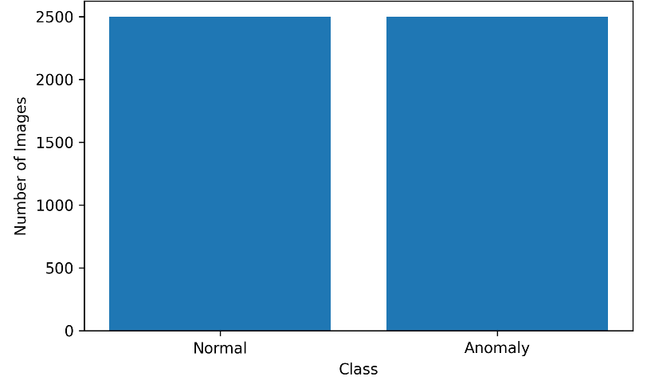
Figure 3.Code used to create the class distribution chart shown in Figure 2
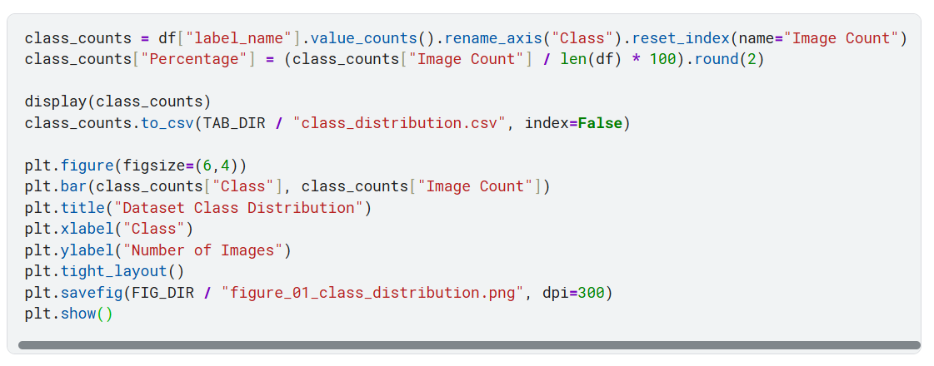

Table 3. Dataset and split summary generated from CSV outputs
Item | Value
Total working images | 5,000
Normal / non-violence images | 2,500
Anomaly / violence images | 2,500
Training images | 3,500
Validation images | 750
Test images | 750
Image size used in notebook | 160 × 160

Resizing, normalisation and label encoding were done as part of the pre-processing. Resizing was performed as the size of input required by the models has to be fixed. The algorithms were able to work with the normalized values of the pixels. Normal images were encoded as 0 and anomaly images as 1 with label encoding technique.
Data was obtained from two data routes. The classical approach to ML applied extracted numerical features from the image. This was used for Isolation Forest, KNN, Linear SVM, Logistic Regression, Random Forest and MLP. Deep learning path directly applied image tensors. This was for the small CNN transfer learning model & MobileNetV2 transfer learning model. This design was much more general and useful, testing the feature-based learning and the image-based learning.

Algorithms tested
Eight models were selected for testing. This is crucial as the brief's requirements include understanding of anomaly detection algorithms and machine learning algorithms suitable for classification. The selected models were chosen to test different ways of separating violent and non-violent images, from outlier-based detection to feature-based classifiers and image-based transfer learning (Ullah et al., 2023; Kaur and Singh, 2024).
Because of the nature of the unsupervised anomaly detection, we chose Isolation Forest as the main algorithm; the idea is that abnormal instances are likely to be split more easily than normal instances by random splits (Liu, Ting & Zhou, 2008). KNN was added to the list of classifiers as a distance-based one, since it classifies based on the most similar examples found in feature space (Cover and Hart, 1967). Linear SVM was used as a high-dimensional supervised baseline approach since support vector methods are based on the ability to separate classes by a decision boundary (Cortes and Vapnik, 1995). Using a Random Forest as an ensemble model was chosen due to the increasing stability of the predictive model created (Breiman, 2001). The MLP and CNN models were neural-network based learning, in which layered models were learning the non-linear relationships in data (Goodfellow, Bengio & Courville, 2016). The choice of MobileNetV2 as a transfer learning model was made due to its being a lightweight convolutional model which was designed to be efficient in image classification (Sandler et al., 2018).
Table 4. Model selection matrix
Model | Family | Input route | Main purpose | Key limitation
Isolation Forest | Unsupervised anomaly detection | Extracted features | Tests outlier-based detection | Weak result on image features
KNN | Distance-based ML | Extracted features | Strong simple classifier | Less scalable with large stored data
Linear SVM | Supervised ML | Extracted features | High-dimensional baseline | Linear boundary may be limited
Logistic Regression | Supervised baseline | Extracted features | Simple reference model | Too basic for complex images
Random Forest | Ensemble ML | Extracted features | Robust non-linear classifier | Does not learn spatial image features
MLP | Neural network | Extracted features | Best F1-score in experiment | Not direct image-based deployment
Small CNN | Deep learning | Image tensors | Tests CNN from scratch | Underperformed
MobileNetV2 | Transfer learning | Image tensors | Practical image-based model | Still image-based, not temporal video

The algorithm strategy was not to take it for granted that deep learning is always the best. Rather, the same test set was used to compare classical models with neural models. This made the result more reliable and enabled the report to provide an explanation of the success and failure of various models and why some were statistically sound and the other more viable for deployment.

Final algorithm selection and justification
Final practicality and performance were the basis for the decision on the final model. Based on the output file final_model_comparison.csv, it was observed that the MLP classifier gave the best score for F1 and MobileNetV2 gave the best score for anomaly recall. Significance of this difference is that one should not judge a security anomaly system by only one factor. Recall is particularly vital for a CCTV alert system as it would indicate that a violent incident has gone unrecorded as a false negative.
Table 5. Final model selection evidence from notebook outputs
Decision point | Best model/result | Evidence from output
Highest F1-score | MLP Classifier | F1 = 0.9497
Highest anomaly recall / TPR | MobileNetV2 Transfer | Recall = 0.9680
Fastest strong model | KNN Classifier | F1 = 0.9415, training time = 0.32 seconds
Weakest model | Isolation Forest | F1 = 0.4201
Final operational choice | MobileNetV2 Transfer | Direct image-based model with strongest anomaly recall

The best numerical classifiers of the experiment were the MLPs. But choosing MobileNetV2 as the final operational model was decided as it takes images directly as input and is more natural to work with in the CCTV image pipeline. Keras Applications are deep learning models that come with pre-trained weights for prediction, feature extraction and fine-tuning (Keras, 2024).
TensorFlow also offers a model called MobileNetV2, which is an image classification model that uses the weights from ImageNet (Sandler et al., 2018; Chollet, 2021). KNN was both fast and accurate, but could be less efficient when it comes to a very large stored set. Thus, MobileNetV2 offers the optimal compromise between recall and image-based processing and deployment.

TASK 2

System Implementation

Programming language and development environment
The system has been developed in Python running in a Kaggle Notebook. Python was selected as it offers support for the entire workflow of the machine learning project: data handling, image processing, model training, evaluation, and visualization (Géron, 2022). Important libraries used were: pandas, NumPy, matplotlib, scikit-learn, TensorFlow and Keras. The classical machine learning models and metric calculations were done by using scikit-learn. It is state that scikit-learn was used because the same style of code could train and evaluate several classical models, which made the comparison easier to keep consistent (Pedregosa et al., 2011).
The Kaggle development environment was chosen because they offer access to publicly-available datasets as well as the ability to execute notebooks and use GPU acceleration. A P100 GPU was used to run the notebook. This could be helpful for training CNN and MobileNetV2 and classical models could be trained in a quick manner using extracted image features. Also the notebook structure facilitated the report evidence as the workflow was well detailed and split in different stages: loading, pre-processing, modelling, evaluation and output export.

Data acquisition and preparation
The notebook first scanned the Kaggle input folder and saved the discovered image paths and labels into a dataset index file. The original folders were renamed to Normal and Anomaly, depending on whether they corresponded to non-violence or violence. This kind of mapping was appropriate for the project, as the goal was to locate a security risk scene, not a person.
A balanced working sample of 5,000 images was used. This determination was done for technical and for evaluating purposes. In a nutshell, it decreased the notebook running time and allowed for the experiment to be done on Kaggle. It did not have a class imbalance problem; from an evaluation perspective, the model could be accurate but favouring one class. The notebook split the files into train_split.csv, validation_split.csv and test_split.csv.
Figure 4. Sample normal and anomaly images from the prepared dataset
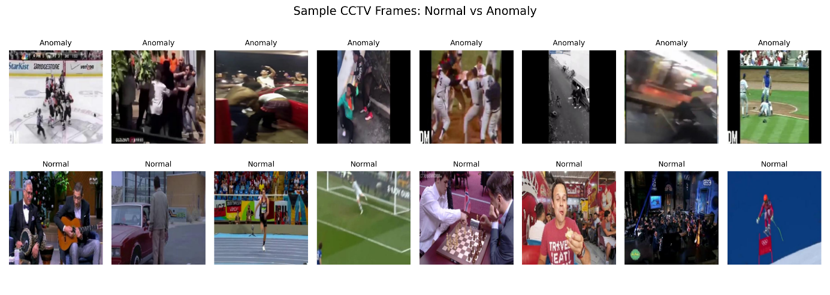
Figure 5. Code used to sample and display normal/anomaly images
shown in Figure 4
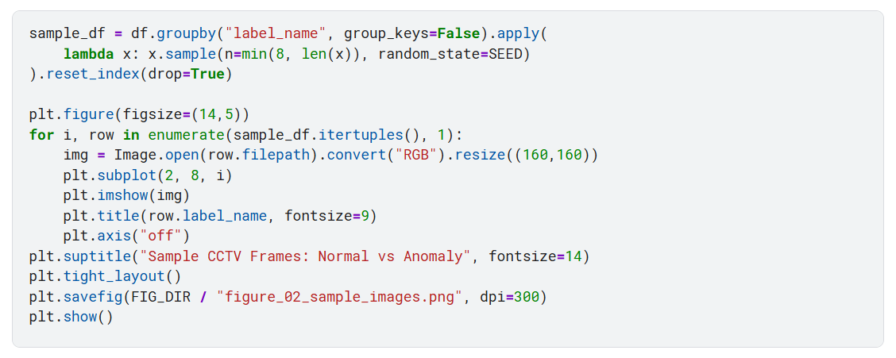
The images were then re-sized to 160 × 160 for the notebook workflow. Before training the images were normalised. In the case of feature-based models, image arrays were transformed to numerical feature files. In the case of models based on images, images were supplied in the form of tensors to CNN and MobileNetV2 pipelines. The two-routes enabled the project to run the classical algorithms and deep learning models, where all the models were not required to have the input in the same format.

Model training and optimization
The training process of the model was split into classical machine learning and deep learning. The classical route comprised of Isolation Forest, KNN, Linear SVM, Logistic Regression, Random Forest and MLP. These models were learnt from the feature arrays which were extracted and stored as .npy files. This reduced training time since the same images were not recycled in/out of the notebook and re-sized.
Transfer learning with MobileNetV2 and a small CNN were incorporated in the deep learning route (Chollet, 2021). The small CNN was trained from scratch to see if we could get a simple CNN to do the job. This weaker result indicated that for this data set and training protocol, a simple CNN was insufficient. MobileNetV2 applied transfer learning, in which the classification head was trained to classify normal/abnormal while reusing the trained base (convolutional) network. In the MobileNetV2 route, the pre-trained convolutional base was reused and only the project-specific classification layers were trained for the normal/anomaly task (Chollet, 2021; Géron, 2022).
Figure 6. MobileNetV2 training and validation accuracy curve
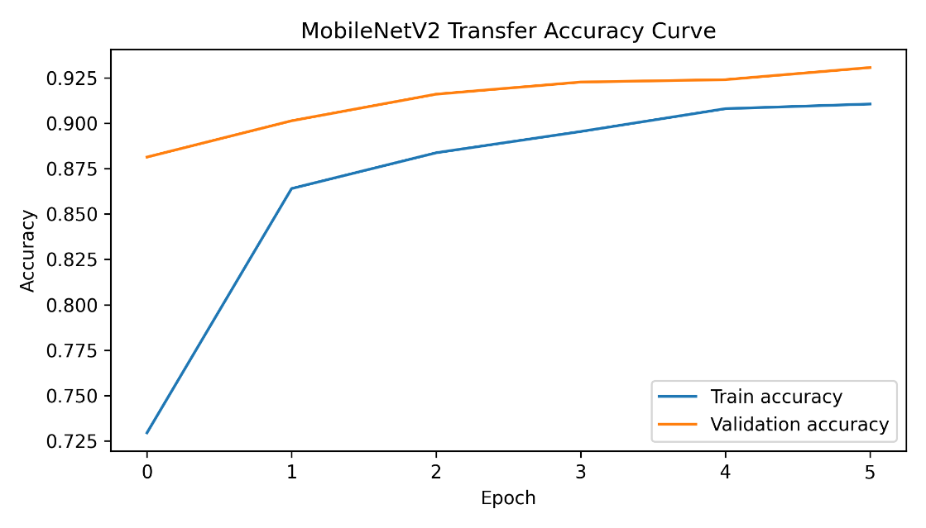
Figure 7. Code used to generate the MobileNetV2 accuracy and validation curves shown in Figures 6
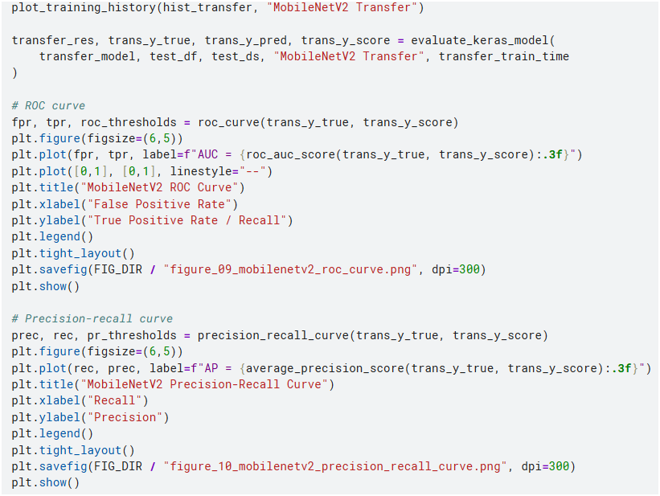
Figure 8. MobileNetV2 training and validation loss curve
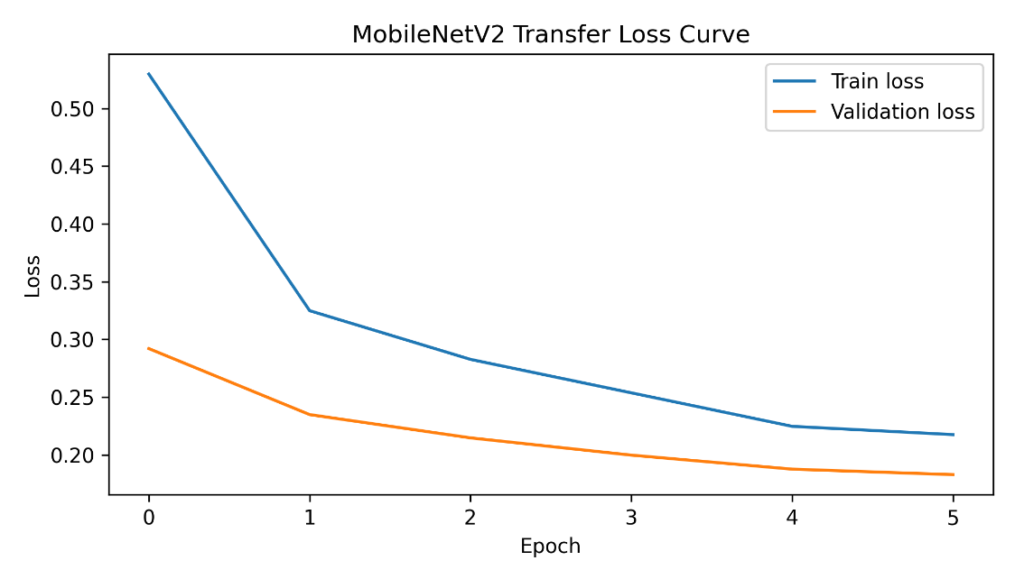
Figure 9. Code used to generate the MobileNetV2 training and validation loss curve shown in Figure 8
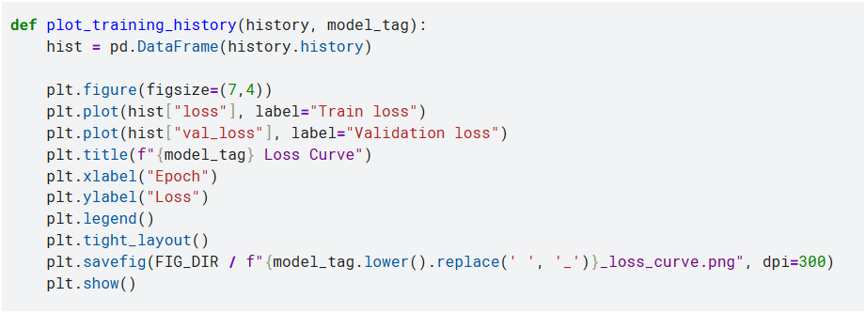
The Training history in MobileNetV2 was consistently increasing in 6 epochs. The training accuracy improved from 0.7294 to 0.9106 and validation accuracy improved from 0.8813 to 0.9307. The value of training loss has also been reduced from 0.5297 to 0.2175. These results indicate that the model has learned meaningful visual patterns without undergoing a lengthy training period.
Table 6. MobileNetV2 training history summary from CSV output
Epoch stage | Training accuracy | Validation accuracy | Training loss | Validation loss
First epoch | 0.7294 | 0.8813 | 0.5297 | 0.2920
Best final epoch | 0.9106 | 0.9307 | 0.2175 | 0.1829

Implementation workflow and generated artefacts
The notebook generated all report evidence products. These included CSV files, image figures, saved models, prediction logs and a packaged ZIP folder. This is helpful, as the answer now can be examined in code, not just words, as well as written explanation.

Table 7. Implementation workflow and generated outputs
Stage | Notebook action | Main output evidence
Dataset loading | Locate image folders and labels | dataset_index.csv
Sampling | Balance 2,500 images per class | class_distribution.csv
Data split | Create train/validation/test sets | split_summary.csv
Feature preparation | Save arrays for ML models | .npy feature files
Classical training | Train six feature-based models | classical_model_results.csv
CNN training | Train small CNN baseline | CNN history and confusion matrix
Transfer learning | Train MobileNetV2 | Training curves and model file
Evaluation | Compare all models | final_model_comparison.csv
Alert demo | Produce example alerts | security_alert_log.csv
Export | Package all assets | Output ZIP folder

Implementation challenges
The first challenge was in selecting a dataset which was appropriate for the short duration of the challenge, yet also workable. A much larger anomaly data set was one that was considered initially, but didn't work because it had a very large number of frames in it and was too slow. The last violence/non-violence data set provided a better combination of academic value and execution time.
Comparing models that have varying input requirements was the second challenge. Numerical features are needed for classical models and image tensors are needed for CNN-based models. This was done by splitting the data set but taking different input routes. This ensured the comparison was fair on the dataset level but also enabled each model type to run.
The third difficulty was in understanding the final choice of model. Although the MLP performed best in terms of F1 score, the MobileNetV2 was more appropriate as the final model for CCTV's given its ability to accept images and its high anomaly recall. This decision is more feasible in a security application since it is more severe to miss an occurrence of violence than to generate some false alarms.

Evaluation and Testing
Testing plan was set to test on unseen data to check accuracy, performance and robustness. All of the models tested used the same image set of 750 images, including 375 normal images and 375 anomaly images. This was done so that all of the models are evaluated using the same examples. Main test cases were point anomaly detection whereby a single image frame had to be classified as normal or violent/anomalous.
The evaluation combined overall accuracy with security-focused measures such as anomaly recall, false positive rate and false negative rate. F1-score, ROC-AUC and average precision were also reported so that the models could be compared beyond accuracy alone (Landauer et al., 2023). The following metrics were chosen because that's not the only measure of a successful security system. Precision refers to the reliability of the alerts whereas recall refers to the number of anomalies found. The documentation of Scikit-learn classification reports indicates that precision, recall, F1-score and support are included, and that recall (for the positive class in binary classification) is equivalent to sensitivity or TPR (scikit-learn developers, 2025a). The F1 score was also employed, which is a combination of precision and recall into a single score (scikit-learn developers, 2025b).
Figure 10. Final F1-score comparison across all tested models
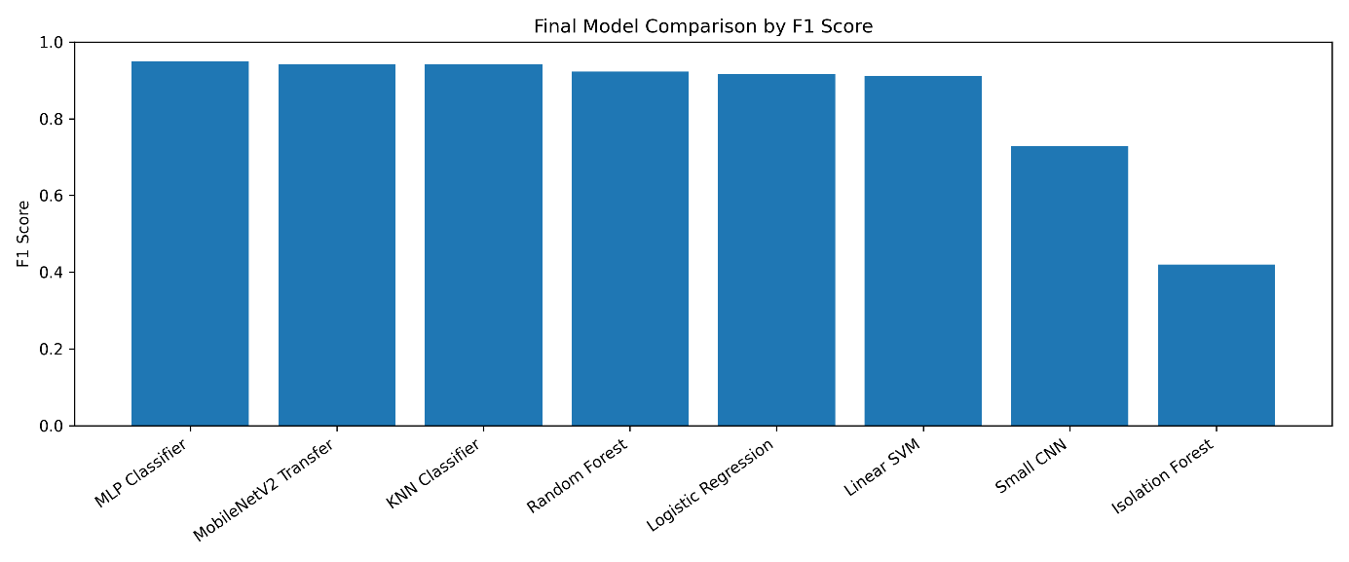
Figure 11. Code used to generate the final F1-score model comparison shown in Figure 10
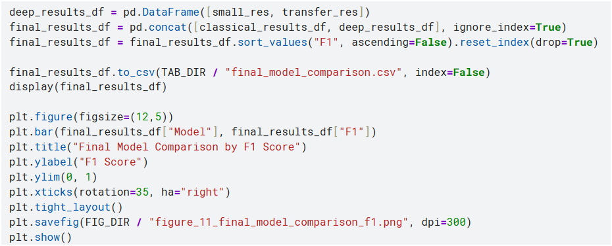
Table 8. Final performance comparison of all tested models
Model | Accuracy | Precision | Recall / TPR | F1-score | ROC-AUC | Time (s)
MLP Classifier | 0.9493 | 0.9423 | 0.9573 | 0.9497 | 0.9910 | 3.26
MobileNetV2 Transfer | 0.9400 | 0.9167 | 0.9680 | 0.9416 | 0.9838 | 43.92
KNN Classifier | 0.9400 | 0.9188 | 0.9653 | 0.9415 | 0.9829 | 0.32
Random Forest | 0.9213 | 0.9072 | 0.9387 | 0.9227 | 0.9767 | 5.77
Logistic Regression | 0.9160 | 0.9084 | 0.9253 | 0.9168 | 0.9812 | 0.90
Linear SVM | 0.9120 | 0.9077 | 0.9173 | 0.9125 | 0.9757 | 1.73
Small CNN | 0.7520 | 0.8039 | 0.6667 | 0.7289 | 0.8111 | 26.10
Isolation Forest | 0.5693 | 0.6429 | 0.3120 | 0.4201 | 0.6255 | 0.47

The results reveal that the best performance is obtained by the MLP classifier, which is 0.9497. KNN and MobileNetV2 came in very close with their accuracy and F1-scores both at 0.9400. The weakest performance was seen on the Isolation Forest, indicating that the feature representation that was extracted was not sufficient for the separation of outliers in this image task. The small CNN also performed below the best models, indicating that training a simple CNN from scratch was not as effective as using either extracted features or transfer learning.
While MLP achieved the best F1-score, the most efficient CCTV in operation was MobileNetV2 with an anomaly recall of 0.9680. In a security system, it is significant as it is worse to miss an anomaly than to get another uncalled for alert. The MobileNetV2 confusion matrix also provides a better understanding of the type of errors.
Figure 12. Confusion matrix for the selected MobileNetV2 model
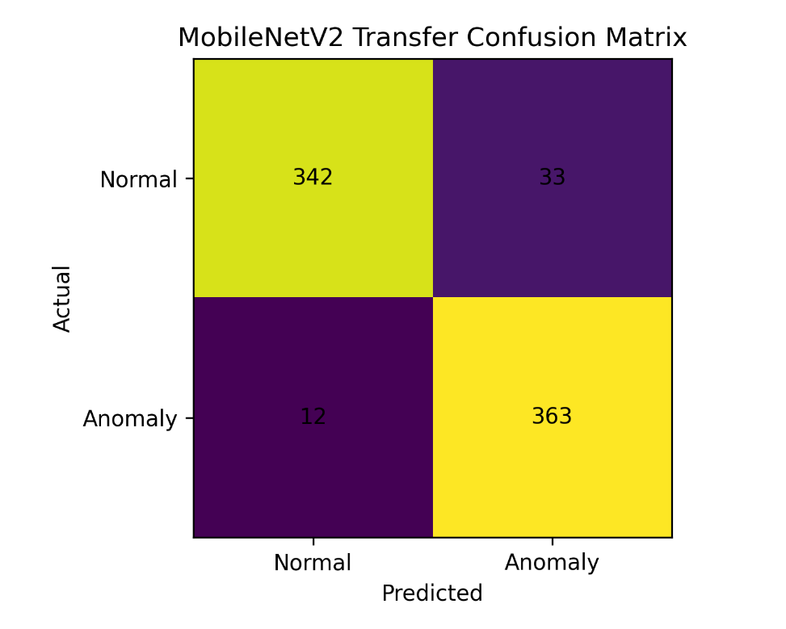
Figure 13. Code used to evaluate MobileNetV2 and generate the confusion matrix shown in Figure 12
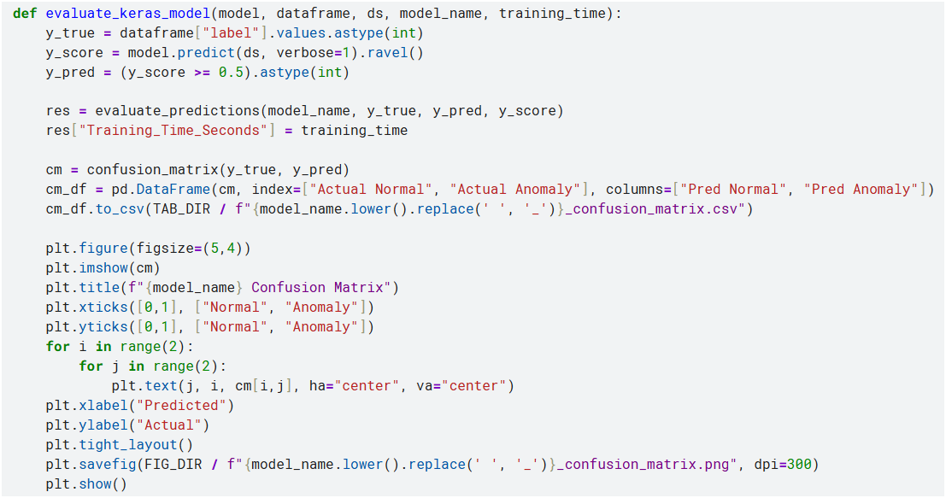
Table 9. MobileNetV2 confusion matrix from test set
Actual class | Predicted Normal | Predicted Anomaly
Actual Normal | 342 | 33
Actual Anomaly | 12 | 363

The accuracy of the selected model on normal image classification is 342 and on anomaly image classification is 363. It generated 33 false positives (normal images classified as violent) and 12 false negatives (images of violence not classified). This gives a False Positive Rate of 33 / 375 = 0.0880 and a False Negative Rate of 12 / 375 = 0.0320. For a system based on security, this is a good trade-off, because the model detected the majority of the violent/anomalous images with a low false negative count.
Table 10. MobileNetV2 class-level classification report
Class | Precision | Recall | F1-score | Support
Normal | 0.9661 | 0.9120 | 0.9383 | 375
Anomaly | 0.9167 | 0.9680 | 0.9416 | 375
Macro average | 0.9414 | 0.9400 | 0.9400 | 750
Weighted average | 0.9414 | 0.9400 | 0.9400 | 750

Based on the class-level result, it could be seen that the model is slightly more successful in detecting anomaly images compared to normal images. This is fine for the purpose since the project is focused on identification of violent events. But the 33 false alerts illustrate why it is still important to have humans review the alerts. An Alert should be interpreted as a call to review – it should not be interpreted as automatic evidence that violence has taken place.
Figure 14. ROC curve for the MobileNetV2 model
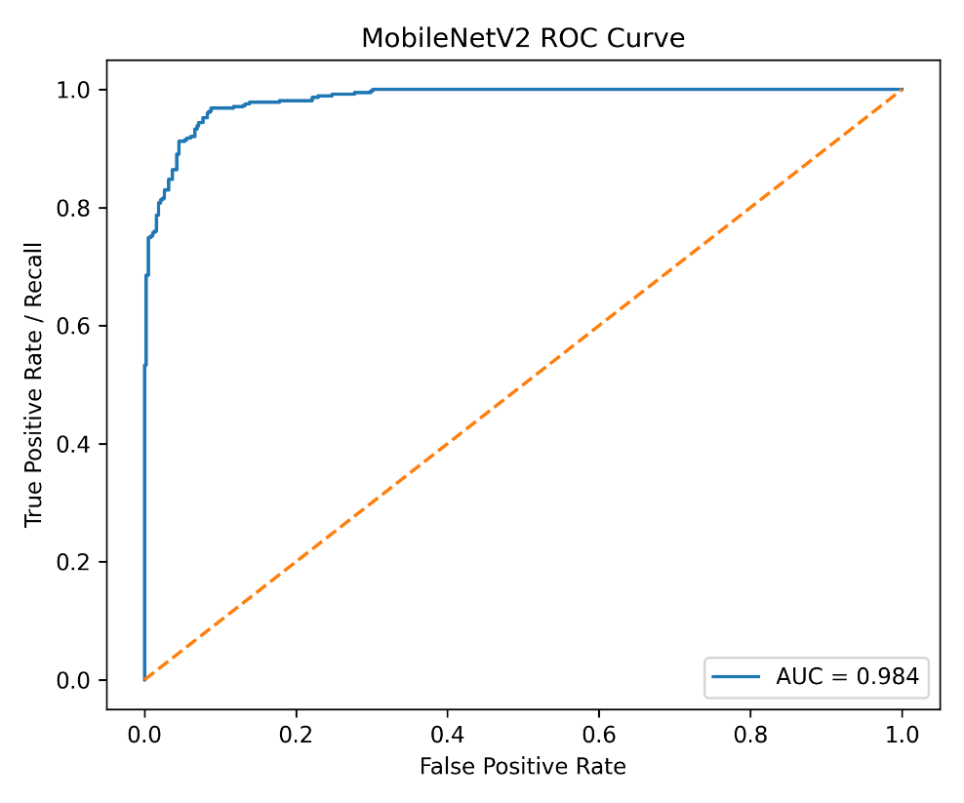
Figure 15. Code used to generate the MobileNetV2 ROC curve shown in Figure 14
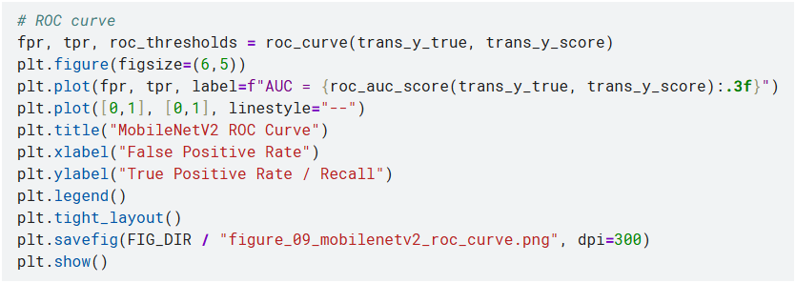
Figure 16. Precision-recall curve for the MobileNetV2 model
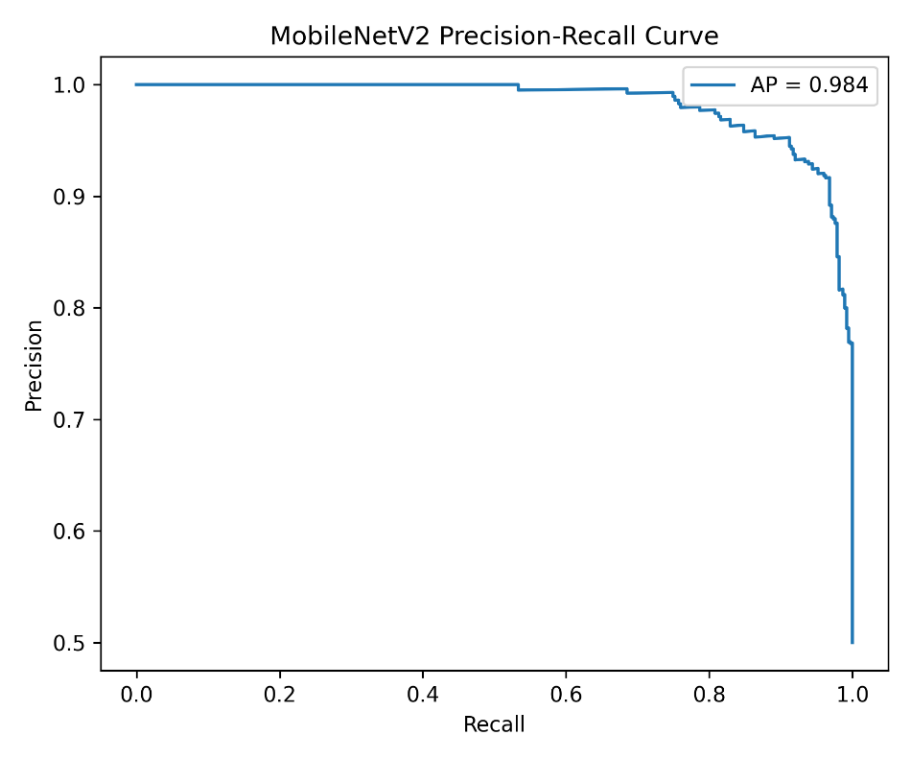
Figure 17. Python code for calculating average precision and generating the MobileNetV2 precision-recall curve in Figure 16
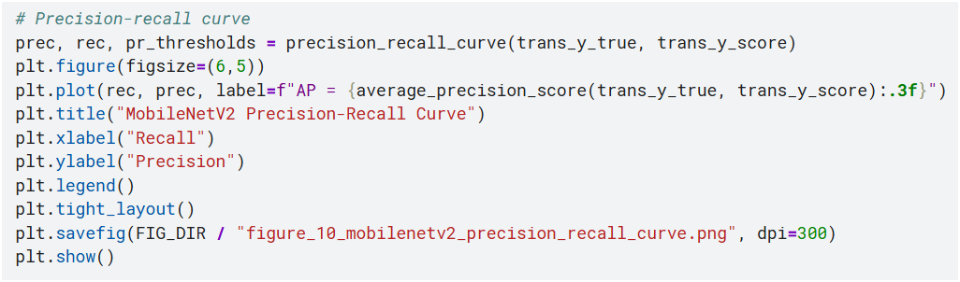
The notebook also created an alert demonstration based on the security_alert_log.csv. This file contained information regarding path in file system and original labels, anomaly probability, predicted status and alert messages. There were 396 possible alert style log records in the alert log. Some were actual anomaly alerts and some normal images were incorrectly identified as anomaly. This is helpful evidence, as it demonstrates the ways in which the output of the model can be translated into a real security process.

Figure 18. Example alert demonstration using test images
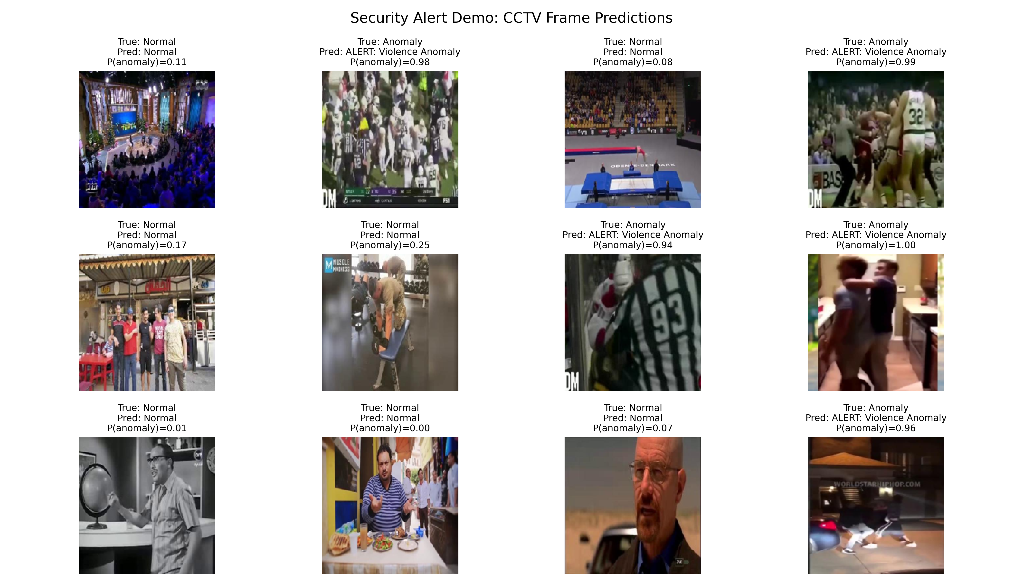
Figure 19. Code used to generate the security alert log and alert demonstration shown in Figure 18
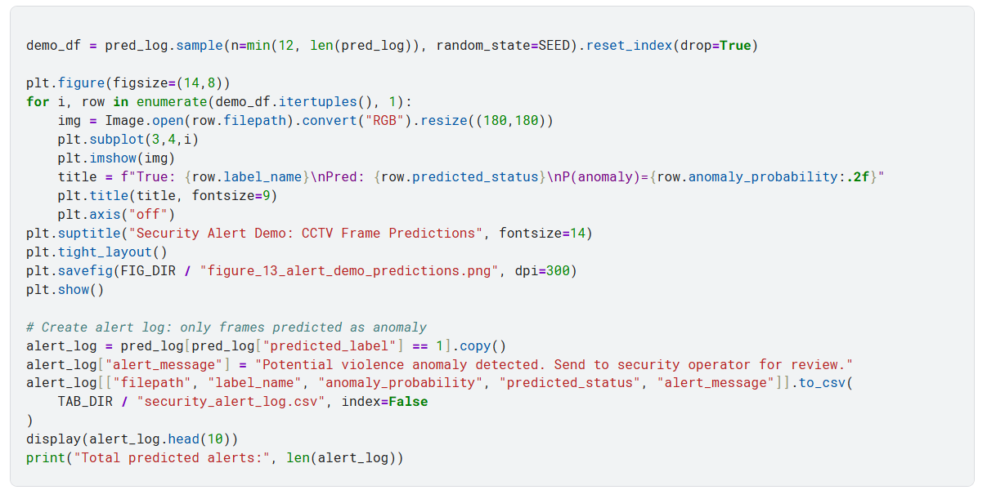
The testing indicates that the project fulfilled the requirements as specified in the brief for implementation and evaluation. The system suggested multiple algorithms, generated measurable outputs and demonstrated how this prediction can be used to provide security alerts. This section includes metrics provided by the assignment brief including True Positive Rate, False Positive Rate, precision and recall.

Future Perspective
The disadvantages are that the system was trained on still images, and not the entire CCTV video. Can recognise when violence is happening in a picture, but not when escalation and/or behaviours are happening over time. Future work is to be done to detect collective anomalies in multiple frames using video-based models such as CNN-LSTM, 3D CNNs or video transformer (Wastupranata, Kong & Wang, 2024).
Another drawback is that this data set is binary. No distinction is made between categories of specific security incidents, such as robbery or vandalism, accident, fire or even crowd panic – just violence or not violence. For the future, a multi-class anomaly data-set should be used and the capability to detect different classes of events tested.
Also there are moral and privacy concerns. If any kind of real CCTV was installed, then controls and restrictions would need to be in place to protect the data associated with any images captured; audit logs and clear retention rules would be required, as images captured by CCTV may contain identifiable people. The Information Commissioner's Office (ICO) has guidance on the legal requirements under the UK GDPR and Data Protection Act 2018 (ICO, n.d.) that organisations when using video surveillance should consider (Mosa, 2024). The system should thus not be an automatic enforcement system, but rather a system for the human decision support.

Conclusion
The project created a violence anomaly detection system using a CCTV camera, python programming, classical machine learning and deep learning using Kaggle dataset. A total of 8 models were tested with the same test set. The highest F1-score was obtained by the MLP classifier and the model that was best performing directly with the image input, which was the MobileNetV2 with the best anomaly recall was chosen as the final running model. The performance of the final (MobileNetV2) model is 94.00% accuracy, 96.80% anomaly recall and 0.9838 ROC-AUC. The project thus showcases an end-to-end anomaly detection system design, preprocessing, model training, and evaluation & alert generation.

References
Chollet, F., 2021. Deep learning with Python. 2nd Edn. Shelter Island, NY.
Géron, A., 2022. Hands-on machine learning with Scikit-Learn, Keras, and TensorFlow. " O'Reilly Media, Inc.".
Goodfellow, I., Bengio, Y. and Courville, A. (2016) Deep Learning. Cambridge, MA: MIT Press.
https Kaggle (n.d.) Violence vs. Non-Violence: 11K Images Dataset. Available at:://www.kaggle.com/datasets/abdulmananraja/real-life-violence-situations (Accessed: 05 May 2026).
Kaur, G. and Singh, S., 2024. Revisiting vision-based violence detection in videos: A critical analysis. Neurocomputing, 597, p.128113.
Keras (2024) Keras Applications. Available at: https://keras.io/api/applications/ (Accessed: 05 May 2026).
Landauer, M., Onder, S., Skopik, F. and Wurzenberger, M., 2023. Deep learning for anomaly detection in log data: A survey. Machine Learning with Applications, 12, p.100470.
Liu, F.T., Ting, K.M. and Zhou, Z.-H. (2008) ‘Isolation Forest’, 2008 Eighth IEEE International Conference on Data Mining, pp. 413–422.
Mosa, M.J., Barhoom, A.M., Alhabbash, M.I., Harara, F.E., Abu-Nasser, B.S. and Abu-Naser, S.S., 2024. AI and ethics in surveillance: balancing security and privacy in a digital world.
Pedregosa, F., Varoquaux, G., Gramfort, A., Michel, V., Thirion, B., Grisel, O., Blondel, M., Prettenhofer, P., Weiss, R., Dubourg, V. and Vanderplas, J., 2011. Scikit-learn: Machine learning in Python. the Journal of machine Learning research, 12, pp.2825-2830.
Sandler, M., Howard, A., Zhu, M., Zhmoginov, A. and Chen, L.-C. (2018) ‘MobileNetV2: Inverted residuals and linear bottlenecks’, Proceedings of the IEEE Conference on Computer Vision and Pattern Recognition, pp. 4510–4520.
scikit-learn developers (2025a) classification_report. Available at: https://scikit-learn.org/stable/modules/generated/sklearn.metrics.classification_report.html (Accessed: 05 May 2026).
scikit-learn developers (2025b) f1_score. Available at: https://scikit-learn.org/stable/modules/generated/sklearn.metrics.f1_score.html (Accessed: 05 May 2026).
Sengonul, E., Samet, R., Abu Al-Haija, Q., Alqahtani, A., Alsemmeari, R.A., Alghamdi, B., Alturki, B. and Alsulami, A.A., 2025. Abnormal event detection in surveillance videos through LSTM auto-encoding and local minima assistance. Discover Internet of Things, 5(1), p.32.
Ullah, F.U.M., Obaidat, M.S., Ullah, A., Muhammad, K., Hijji, M. and Baik, S.W., 2023. A comprehensive review on vision-based violence detection in surveillance videos. ACM Computing Surveys, 55(10), pp.1-44.
Wastupranata, L.M., Kong, S.G. and Wang, L., 2024. Deep learning for abnormal human behavior detection in surveillance videos—A survey. Electronics, 13(13), p.2579.

AI-use declaration
Generative AI was used as a support tool for planning the report structure, checking alignment with the assignment brief, improving clarity of written explanations and organising the notebook evidence into report sections. The dataset selection, notebook execution, generated figures, CSV outputs, model results and final interpretation were reviewed by the student. The final submission reflects the student’s own understanding of the implemented anomaly detection system.

Appendices

Appendix A: Additional figures
Appendix figure | File name | Purpose
Appendix Figure A1 | figure_03_classical_model_comparison.png | Classical model comparison
Appendix Figure A2 | figure_04_classical_training_time.png | Training time comparison
Appendix Figure A3 | figure_12_final_model_comparison_recall.png | Recall comparison
Appendix Figure A4 | small_cnn_accuracy_curve.png | Small CNN accuracy behaviour
Appendix Figure A5 | small_cnn_loss_curve.png | Small CNN loss behaviour
Appendix Figure A6 | small_cnn_confusion_matrix.png | Small CNN prediction errors

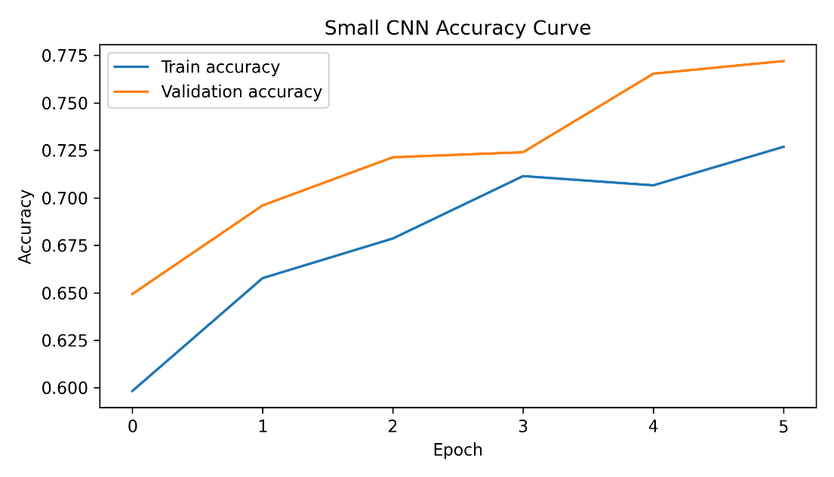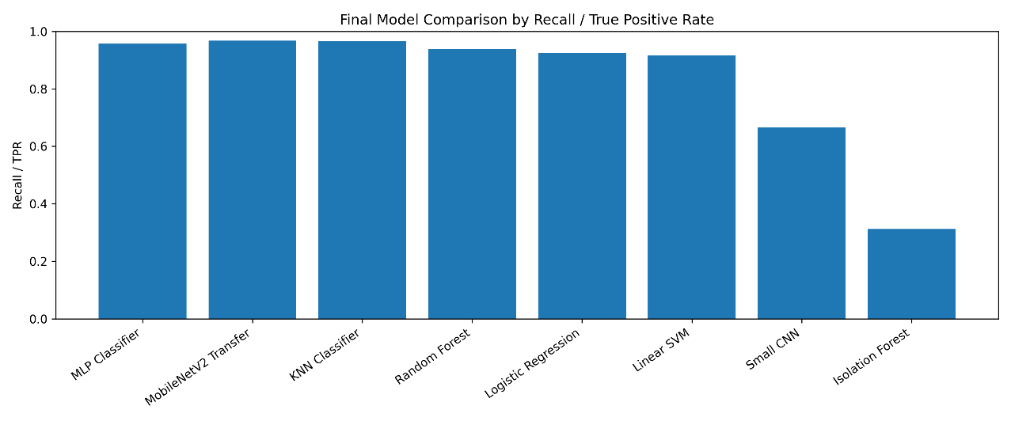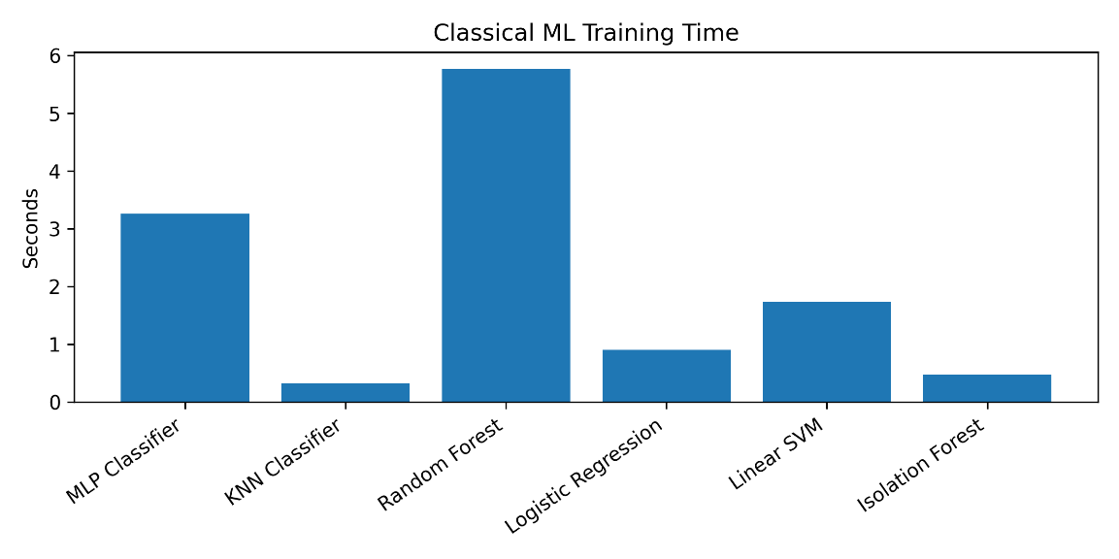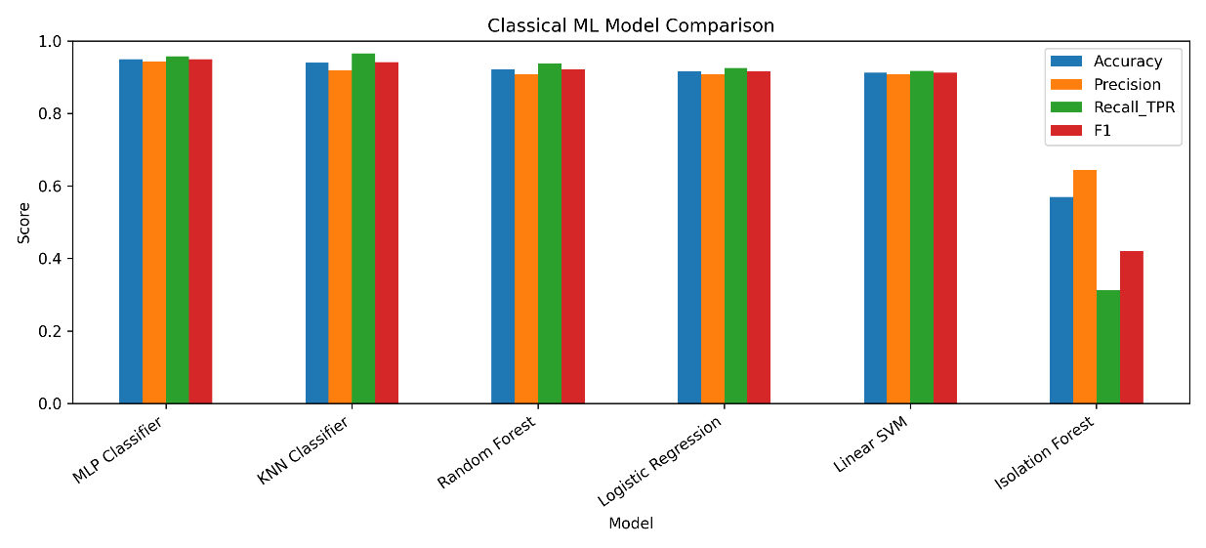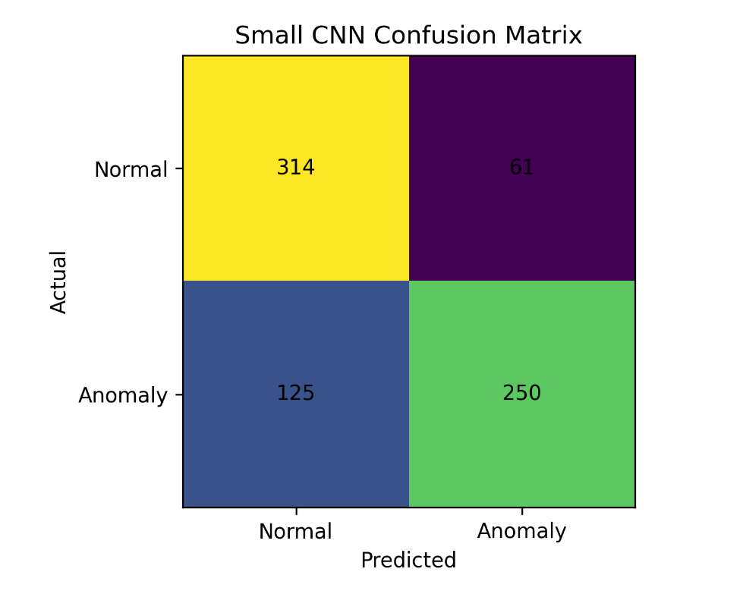

Appendix B: CSV and output evidence
Appendix table | CSV file | Purpose
Appendix Table B1 | class_distribution.csv | Confirms balanced dataset
Appendix Table B2 | split_summary.csv | Confirms train/validation/test split
Appendix Table B3 | classical_model_results.csv | Gives full classical model results
Appendix Table B4 | mobilenetv2_training_history.csv | Shows epoch-by-epoch learning
Appendix Table B5 | small_cnn_classification_report.csv | Shows small CNN detailed result
Appendix Table B6 | mobilenetv2_test_prediction_log.csv | Stores final test predictions
Appendix Table B7 | security_alert_log.csv | Shows generated alert records
Appendix Table B8 | report_asset_index.csv | Lists report assets produced by the notebook

